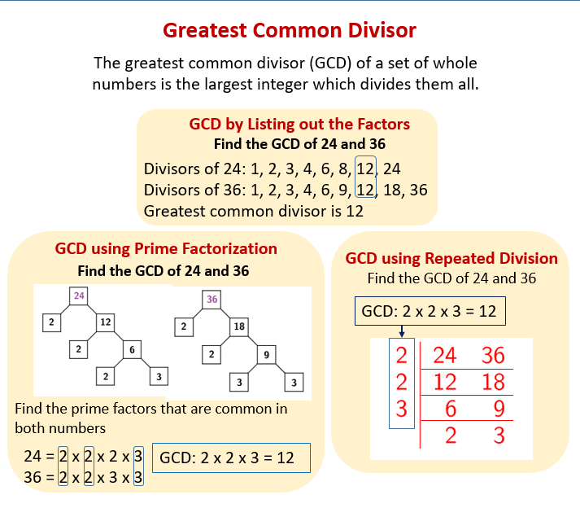

Calculate the greatest common divisor of the following numbers:

Example

GCD (128, 196) = ?

Solution:

$$128=2∙64=2∙2∙32=2∙2∙2∙16=2∙2∙2∙2∙8=2∙2∙2∙2∙2∙4=2∙2∙2∙2∙2∙2∙2$$

$$196=2∙98=2∙2∙49=2∙2∙7∙7$$

so, we can see the common divisors:

$$128=2∙2∙2∙2∙2∙2∙2$$

$$196=2∙2∙7∙7$$

that means 4 can divide both 128 and 196.

Answer: GCD(128, 196) = 4

**Exercise:**

1. GCD(648,  324)
2. GCD(102,  204)
3. GCD(966,  345)
4. GCD(396,  660)
5. GCD(604,  453)
6. GCD(910,  390)
7. GCD(460,  575)
8. GCD(230,  805)
9. GCD(438,  146)
10. GCD(783,  348)

Each problem gains you 10 marks.